EXPERIMENT- 38
Face Detection using Haar Cascade
Aim
To write a Python code to detect faces from an image using Haar Cascade classifier in OpenCV.
Code
from google.colab import files
import cv2
from google.colab.patches import cv2_imshow
uploaded = files.upload()
image_path = list(uploaded.keys())[0]
face_cascade = cv2.CascadeClassifier(
cv2.data.haarcascades + 'haarcascade_frontalface_default.xml'
)
img = cv2.imread(image_path)
gray = cv2.cvtColor(img, cv2.COLOR_BGR2GRAY)
faces = face_cascade.detectMultiScale(
gray,
scaleFactor=1.3,
minNeighbors=5
)
for (x,y,w,h) in faces:
cv2.rectangle(img,(x,y),(x+w,y+h),(255,0,0),2)
cv2_imshow(img)

Input & Output Image
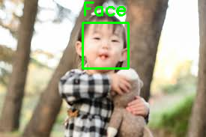
Result
Thus, the faces were successfully detected using Haar Cascade classifier in OpenCV.

